A Startling Revelation
By Howard “Cork” Hayden

Kevin Trenberth [2] is now emphasizing the difference between global heating (a process in which the earth absorbs more heat than it emits) and global warming (an ongoing increase in temperature). Respectively, they are measured in watts per square meter (W/m2) and degrees per unit time (ºC/decade or ºC/century), both quantities averaged over the spherical shape of the earth. He emphasizes that they are different things and goes further to assert that the important quantity to measure is the former, global heating. [Boldface added]

Before going into details, let us consider a purely hypothetical problem of calculating the temperature rise in a perfectly insulated room that has chairs, tables, a linoleum floor, walls and ceiling made of drywall, a tub containing 100 kg of water that is 10ºC warmer than the air in the room, five glasses that each have 3 ice cubes, and a bunch of other stuff. Now, presume that you add some quantity of heat to the room (say, by using a 1,000-watt heater for one hour). How much does the temperature of the room rise eventually? With enough data, a good computer, and a lot of hard work, you can do the calculation.

A similar calculation for the Third Rock from the Sun would require reams of data and a supercomputer to process it all. For example, consider a certain amount of energy added to the top 100 meters of the ocean’s surface. How much does that raise the temperature of the surface of the ocean—and when? What if that energy is absorbed in the top 10 meters or only one meter instead? What if (say) 2 W/m2 average solar flux is absorbed by a puddle that is 10 cm deep? What if 2 W/m2 is absorbed by sand in the Sahara? It is a fool’s errand to do the calculations because the uncertainties in the result—both the final temperatures and the timing— are huge.

On the other hand, if the average temperature of the earth’s surface goes up a little, our planet will emit an average of 5.47 W/m2 for each 1ºC (5.2 W/m2 per degree if you use an emissivity of 0.95), as you can show from the Stefan-Boltzmann law, using a slide rule. All climate models attempt to determine the temperature rise from presumed net heat absorption but none—repeat NONE—use the Stefan-Boltzmann law to check their results.

Let us begin with a couple of very basic principles that apply to all bodies in the solar system except those with heat sources other than the sun. At equilibrium, bodies send as much heat to space as they absorb from the sun:

Heat radiated to space = Solar heat absorbed

The heating to which Trenberth refers is the dis-equilibrium case in which the heat absorbed from the sun exceeds the heat radiated to space. For all such bodies, at equilibrium or not,
Solar heat absorbed = sunlight at orbit – reflected sunlight

This equation is represented in Figure 1 at the top left as 240 = 340 –100, all in watts per square meter.

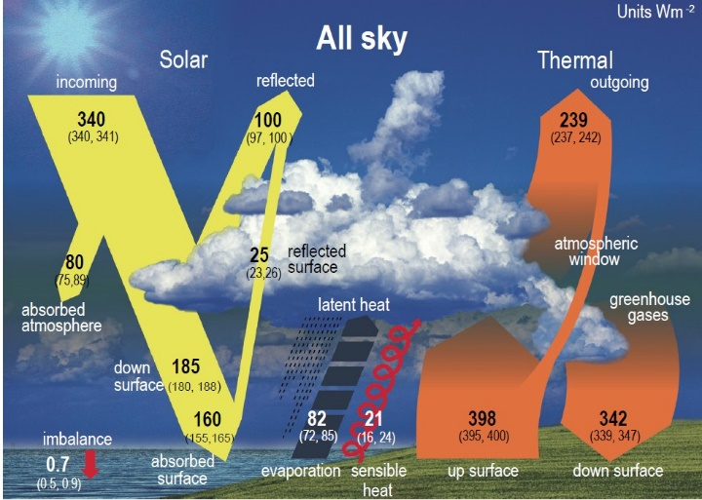
Figure 1: IPCC’s heat-balance drawing (Fig. 7.2) from its Sixth Assessment Report.

Both the intensity of sunlight at orbit and the albedo of the planet affect the absorbed sunlight. To determine whether there is any heating of the earth, we need to measure—with considerable accuracy—How much sunlight there is at our orbit, how much sunlight is reflected, and how much heat the earth radiates to space. The measured numbers (See Fig. 1) reported in IPCC’s Sixth Assessment Report (2021) are close to 340 (340, 341) W/m², 100 (97, 100) W/m², and 239 (237, 242) W/m², with the range of measured values shown in parentheses. For the heating, you could get anywhere from +7 W/m² (341 – 97 –237) to –2 W/m² (340 – 100 – 242). IPCC’s imbalance is given as +0.7 (0.5, 0.9) W/m². Somehow, a 9 W/m² uncertainty in the energy imbalance got whittled down to a 0.4 W/m² uncertainty. [Boldface added]

Such is the difficulty of “measuring” small quantities by subtracting one large quantity from another. The uncertainties in the large quantities are often greater than the small difference you’re trying to measure. Whenever possible, you should measure the difference directly, but in this case it is impossible.

NASA’s Gavin Schmidt has published a heat-balance diagram (Fig. 2) showing 10-year averages of measured quantities supposedly to a stunning accuracy of about one part in 4,000 (a minuscule 0.025%) in all measurements, in which the net absorbed heat is 0.6 W/m².

Schmidt correctly recognizes that the greenhouse effect amounts to the difference between the surface radiation and the radiation to space [3]:

Thus, there must be a large amount of IR absorbed by the atmosphere (around 158 W/m²)- a number that would be zero in the absence of any greenhouse substances.

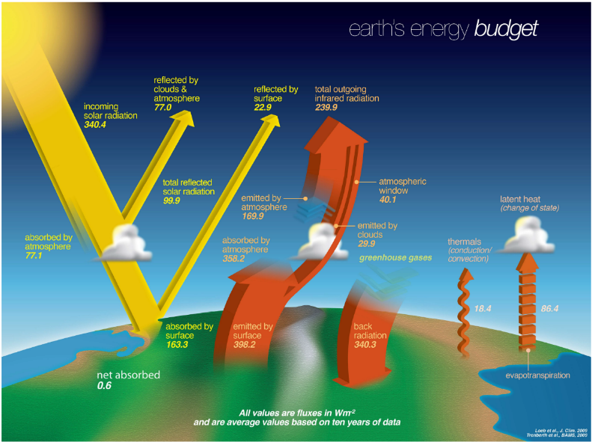
Figure 2: Heat-balance diagram, with values averaged over 10 years from Gavin Schmidt [3]

Schmidt discusses greenhouse gases and concludes [3]:
Thus, the RF [radiative forcing] for a doubling of CO₂ is likely 3.9±0.5 W/m… Converting the estimate for doubled CO₂ to a more useful factor gives ~0.75°C/(W/m²).
The reciprocal of ~0.75 °C/(W/m²) is 1.33 W/(m²ºC), which means that the radiative forcing for CO₂ can block 1.33 W/m² for each 1ºC of temperature increase. How can that possibly block an increase of surface IR of 5.47 W/m² for each 1ºC as demanded by the Stefan-Boltzmann law? [Boldface added]

It can’t.

Did I mention that climate modelers have never used the Stefan-Boltzmann law to check their results?
The mission of the CERES satellite system, begun in 1997, is to measure the Earth’s Energy Imbalance (EEI) (equivalent to Trenberth’s “heating”). The project involves enormous amounts of high-precision data.

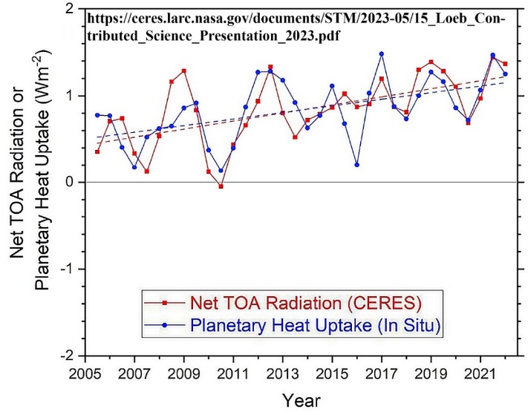
Figure 3: The CERES results [4] for planetary heating, 2002-2022, showing an increase from ca. 0.5 W/m² to about 1.1 W/m². TOA means “Top of Atmosphere.”

Unlike the usual reports coming from Trenberth, Schmidt, the IPCC and others, Normal Loeb’s CERES report [4] makes no reference to CO₂ whatsoever. The really important fact found in the Conclusions [4] is:

The EEI trend is primarily associated with an increase in absorbed solar radiation (ASR) partially offset by an increase in OLR [Outgoing longwave radiation). … Large ASR trend primarily driven by reductions in low and middle clouds.
Let us emphasize this point. The increase in Earth’s Energy Imbalance (EEI; Trenberth’s “heating”) is due primarily to the increase in absorbed solar radiation—the difference between the sunlight incident upon the earth and the amount of reflected sunlight. Further, the solar irradiance (incident sunlight averaged over the spherical shape of the earth) increased only very slightly—from 340.14 W/m² for 2000 to 2010 to 340.17 W/m² for 2013-2023. The Loeb report clarifies that the change is due to the decrease in low and middle clouds. [Boldface added]

In other words, the increase in EEI is due to a decrease in albedo (less reflected sunlight), contrary to IPCC’s calculations that always show an increase in albedo. [Boldface added]

In yet other words, the heating of our planet that we’re seeing is not due to an increase in atmospheric CO₂. This conclusion of the CERES project, which was designed expressly to determine the heat imbalance of the earth and its causes, has been ignored by “climate scientists,” investigative journalists, and politicians, and will continue to be ignored.

Still, this one fact rings the death knell of the “climate crisis.” Unequivocally, it says that the worries about CO₂, “carbon pollution,” “carbon emissions,” and so forth are entirely misplaced. The one fact that the warming we are experiencing is due to changing albedo—NOT CO₂—means that the UN’s COPs (Conferences of Parties), the IPCC’s Assessment Reports, the restrictions on coal, oil, and natural gas, and the belief that we help “save the climate” by killing our cattle are all based on sham science.

[2] Kevin E. Trenberth, “Characterizing Climate Change from Heating, Not Merely Temperature,”

https://www.worldscientific.com/doi/full/10.1142/S2972312424750018

[3] Gavin Schmidt, https://www.realclimate.org/indexphp/archives/2022/07/the-cos2-problem-in-six-easy-steps-2022-update/ [Note: The page has been deleted from Real Climate.]

[4] Norman G. Loeb, “Observational Assessment of Changes in Earth’s Energy Imbalance Since 2000”,

https://ceres.larc.nasa.gov/documents/STM/2023-05/15_Loeb_Contributed_Science_Presentation_2023.pdf

